**TREE QUESTIONS**

Table of Contents

**Theory** 3

What is Tree data structure? 3

What are components of tree? 3

Binary Tree 4

Tree traversal 4

Binary Search Tree 5

Use cases of Tree and its use in system design 5

Array representation of Binary Tree 6

**Important Codes** 7

Binary Search Tree Implementation: 7

Traversals: 8

Level Order Traversal: 9

Morris Traversal: 10

LEVEL 1: **Armature** 14

1. Sum of binary tree 14

2. Search a node in BST 14

3. Count Leaves in binary tree 14

4. N-Ary Tree postorder traversal 14

5. Maximum Depth of binary tree 14

6. Height of binary tree 14

7. Convert a BST to tree with only right nodes. 14

8. Check if two binary trees are same or not. 14

9. Range sum of bst 14

10. Average of levels in binary tree. 14

11. Sum of left leaves 14

12. Invert a binary tree 14

LEVEL 2: **Pro** 15

1. Merge two binary trees. 15

2. Sorted array to BST 15

3. Binary Tree tilt 15

4. Diameter of binary tree 15

5. Subtree of another tree 15

LEVEL 3: **Legend** 16

**SOLUTIONS:** 17

**LEVEL 1:** 17

**LEVEL 2:** 24

# **Theory**

## What is Tree data structure?

A tree is a hierarchical data structure that starts with a root node and consists of connected nodes. It organizes elements in a parent-child relationship, where each node can have multiple children. It is widely used for representing hierarchical relationships and enables efficient searching, insertion, and deletion operations.

## What are components of tree?

1. **Root:** A tree has a unique node called the root, which serves as the starting point of the tree. All other nodes in the tree are descendants of the root.
2. **Nodes:** A tree consists of nodes that are connected by edges. Each node can have zero or more child nodes. Nodes other than the root are referred to as internal nodes, while nodes without any children are called leaf nodes or leaves.
3. **Edges:** Edges are the connections between nodes in a tree. They represent the relationships between the nodes. Each node (except the root) has exactly one incoming edge from its parent node, and it may have zero or more outgoing edges to its child nodes.
4. **Parent and Child Nodes:** Each node in a tree (except the root) has a unique parent node, which is the node directly above it. The parent node is connected to its child nodes through edges. Conversely, child nodes are the nodes directly below a parent node.
5. **Ancestors and Descendants:** An ancestor of a node is any node that exists on the path from the root to that node, excluding the node itself. A descendant of a node is any node that can be reached by following edges from the node, again excluding the node itself.
6. **Path:** A path in a tree is a sequence of nodes connected by edges. It represents the traversal from one node to another within the tree.
7. **Depth and Height:** The depth of a node is the length of the path from the root to that node. The height of a tree is the maximum depth of any node in the tree. The height represents the length of the longest path from the root to a leaf node.
8. **Subtree:** A subtree is a portion of the tree that consists of a node and all its descendants, including their child nodes and their child nodes, and so on.
9. **Degree:** The degree of a node is the number of its child nodes. A node with a degree of zero is a leaf node, while a node with a degree greater than zero is an internal node.

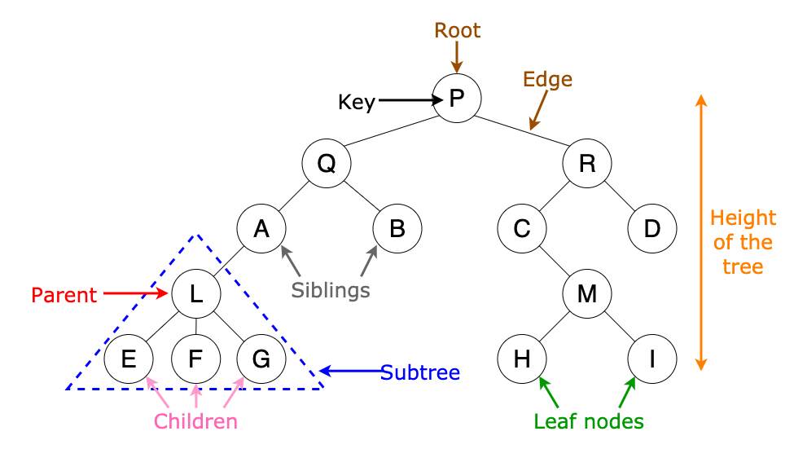

## Binary Tree

A binary tree is a tree data structure where each node can have at most two children, the left child and the right child.

Some types of binary trees are:-

1. **Full Binary Tree:** A full binary tree is a binary tree in which every node has either 0 or 2 children. In other words, every level of the tree is completely filled, except for the last level, which may or may not be full.
2. **Complete Binary Tree:** A complete binary tree is a binary tree in which all levels are completely filled, except possibly for the last level, which is filled from left to right. It ensures that the nodes are as balanced as possible.
3. **Perfect Binary Tree:** A perfect binary tree is a binary tree in which all levels are completely filled with maximum possible nodes. It is a type of complete binary tree with exactly 2^h - 1 nodes, where h is the height of the tree.
4. **Balanced Binary Tree:** A balanced binary tree is a binary tree in which the difference in height between the left and right subtrees of any node is at most 1. It ensures that the height of the tree remains relatively small, resulting in efficient operations.
5. **Degenerate (or Pathological) Binary Tree:** A degenerate binary tree is a binary tree in which each parent node has only one child (either left or right). It essentially becomes a linked list.

## Tree traversal

1. Preorder traversal ( root, left , right)
2. Inorder traversal ( left, root, right)
3. Postorder traversal ( left, right, root)

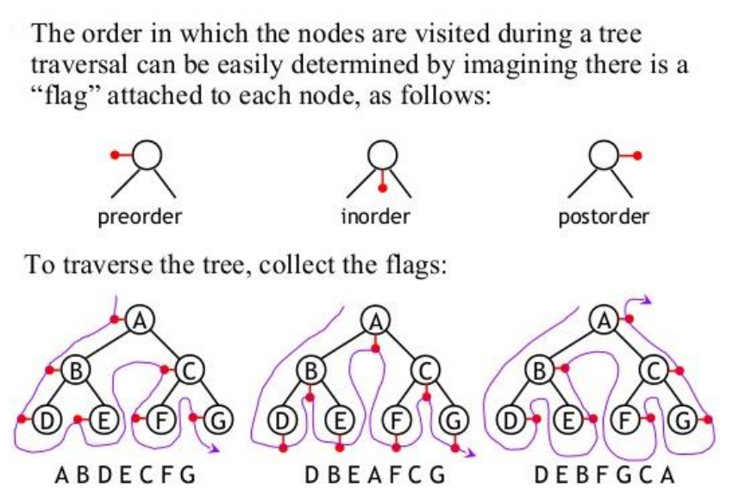

## Binary Search Tree

A binary search tree is a type of binary tree that follows a specific ordering of the nodes. In a binary search tree, the left child of a node contains values that are less than the parent node, and the right child contains values that are greater than the parent node. This ordering property allows for efficient searching, insertion, and deletion operations.

For BST inorder traversal gives numbers in ascending order.

## Use cases of Tree and its use in system design

1. **File System:** Trees are widely used to represent file systems in operating systems. Each directory is represented as a node in the tree, with subdirectories and files as its children.
2. **Routing Algorithms:** Trees are employed in routing algorithms used in networking and telecommunications systems. Examples include the spanning tree protocol (STP) for network redundancy and the hierarchical routing protocol used in the Internet's Border Gateway Protocol (BGP) to organize routing tables.
3. **Data Compression:** Huffman coding is a popular technique for data compression that involves constructing a binary tree where the leaves represent characters and their frequency of occurrence. The resulting tree is used to encode the data in a way that minimizes the amount of storage required.
4. **Compiler Design:** In compiler design, a syntax tree is used to represent the structure of a program.
5. **Database Indexing:** B-trees and other tree structures are used in database indexing to efficiently search for and retrieve data.
6. **User Interfaces:** Trees are utilized in the design of graphical user interfaces (GUIs) to represent the hierarchy of UI elements. This allows for efficient event handling, layout management, and navigation within the UI.

## Array representation of Binary Tree

* If parent is in k th position:

1. Left child – 2K position
2. Right child – 2k+1 position

* If child is in k th position:

Parent position = floor(k/2)

* Size of array needed to represent a binary tree of height h

= Maximum number of nodes possible in binary tree = 2h-1

* For n nodes:- complete binary tree will have minimum height , hence will require least size of array to represent
* Null nodes are also considered in array representation.

[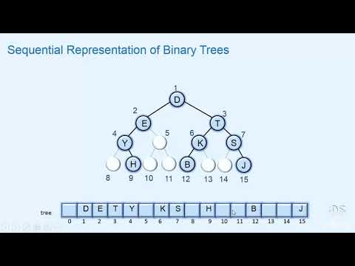](https://www.youtube.com/watch?v=0iHD18D072c)

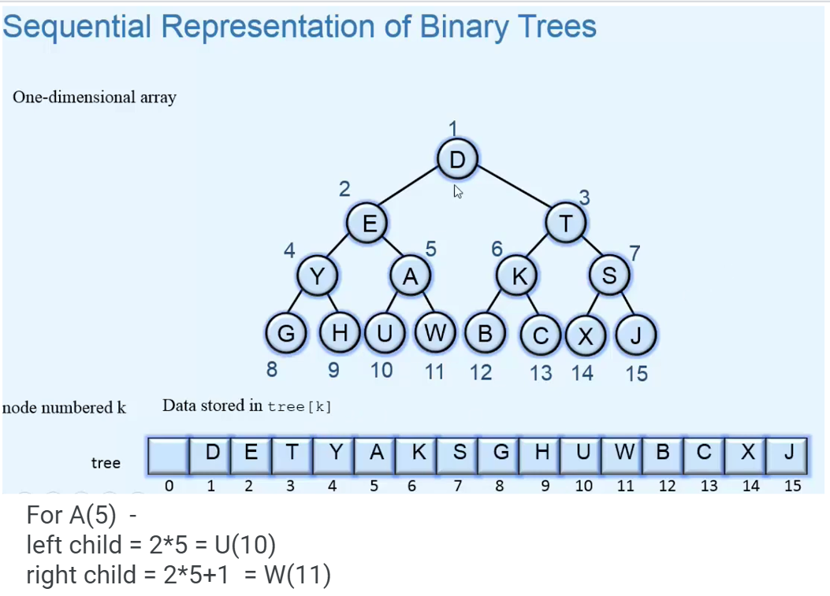

# **Important Codes**

## Binary Search Tree Implementation:

class Node:

    def __init__(self,data):

*self*.data = data

*self*.left = None

*self*.right = None

class BST:

    def __init__(self):

*self*.root = None

    def insert(self,data):

        def insert_recursive(node,data):

            if node is None:

                return Node(data)

            if data < node.data:

                node.left = insert_recursive(node.left,data)

            else:

                node.right = insert_recursive(node.right,data)

            return node

*self*.root = insert_recursive(*self*.root, data)

    def inorder(self):

        def inorder_traversal(node):

            if node is not None:

                inorder_traversal(node.left)

                print(node.data,end=" ")

                inorder_traversal(node.right)

        inorder_traversal(*self*.root)

    def search(self,data):

        def search_recursive(node,data):

            if node is None:

                return False

            if node.data == data:

                return True

            if data < node.data:

                return search_recursive(node.left,data)

            else:

                return search_recursive(node.right,data)

        return search_recursive(*self*.root,data)

bst = BST()

bst.insert(3)

bst.insert(5)

bst.insert(0)

bst.insert(9)

bst.inorder()

print(bst.search(9))

## Traversals:

*# While using global array or variable, always remember to clear it first before use. Else if we run code for more than one output in global array answers get appended for all test cases.*

*# We can also write this without the use of global varialbe, as explained in method 2 and 3.*

*#Method 1 ( use of global variable)*

class Solution:

    res=[]

    def inOrder(self,root):

        if root is None:

            return

*self*.inOrder(root.left)

*self*.res.append(root.val)

*self*.inOrder(root.right)

    def inorderTraversal(self, root: Optional[TreeNode]) -> List[int]:

*self*.res.clear()     *#clear the data*

*self*.inOrder(root)

        return *self*.res

*#Method 2 (without global variable)*

class Solution:

    def inorderTraversal(self, root: Optional[TreeNode]) -> List[int]:

        res = []

        if root is None:

            return res

        res+=*self*.inorderTraversal(root.left)

        res+=[root.val]

        res+=*self*.inorderTraversal(root.right)

        return res

*# Method 3 : One liner*

class Solution:

    def inorderTraversal(self, root: Optional[TreeNode]) -> List[int]:

        return  *self*.inorderTraversal(root.left) + [root.val] + *self*.inorderTraversal(root.right) if root else []

*#For Preorder*

class Solution:

    def preorder_traversal(self, root: Optional[TreeNode]) -> List[int]:

        return [root.val]+*self*.preorder_traversal(root.left) + *self*.preorder_traversal(root.right) if root else []

## https://assets.leetcode.com/uploads/2021/02/19/tree1.jpgLevel Order Traversal:

Problem: so if input is given tree root = [3,9,20,null,null,15,7]

[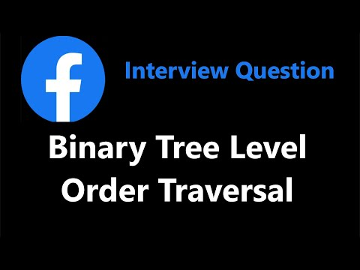](https://www.youtube.com/watch?v=6ZnyEApgFYg)Output should be = [[3], [9,20], [15,7]]

import collections

class Node:

    def __init__(self, key):

*self*.val = key

*self*.left = None

*self*.right = None

def printLevelOrder(root):

    res=[]

    q=collections.deque()

    q.append(root)

    while(q):

        q_len=len(q)

        level=[]

        for i in range(q_len):

            node=q.popleft()

            if node:

                level.append(node.val)

                q.append(node.left)

                q.append(node.right)

        if level:

            res.append(level)

    return res

*# Driver Program to test above function*

if __name__ == '__main__':

    root = Node(3)

    root.left = Node(9)

    root.right = Node(20)

    root.right.left = Node(15)

    root.right.right = Node(7)

    print("Level Order Traversal of binary tree is -")

    print(printLevelOrder(root))

## Morris Traversal:

Morris Traversal is a tree traversal algorithm that allows for the traversal of a binary tree without using recursion or an explicit stack

Recursive solution: O(n) time and O(n) space (function call stack);

**Morris traversal**: O(n) time and **O(1)** space.

In-order Morris Traversal:

🌳 1st case: if left is null, print current node and go right

🌳 2nd case: before going left, make right most node on left subtree connected to current node, then go left 🌳 3rd case: if thread is already pointed to current node, then remove the thread

Iterate until the current node is not NULL.

This is Morris traversal for inorder, can have similar for pre and post order too.

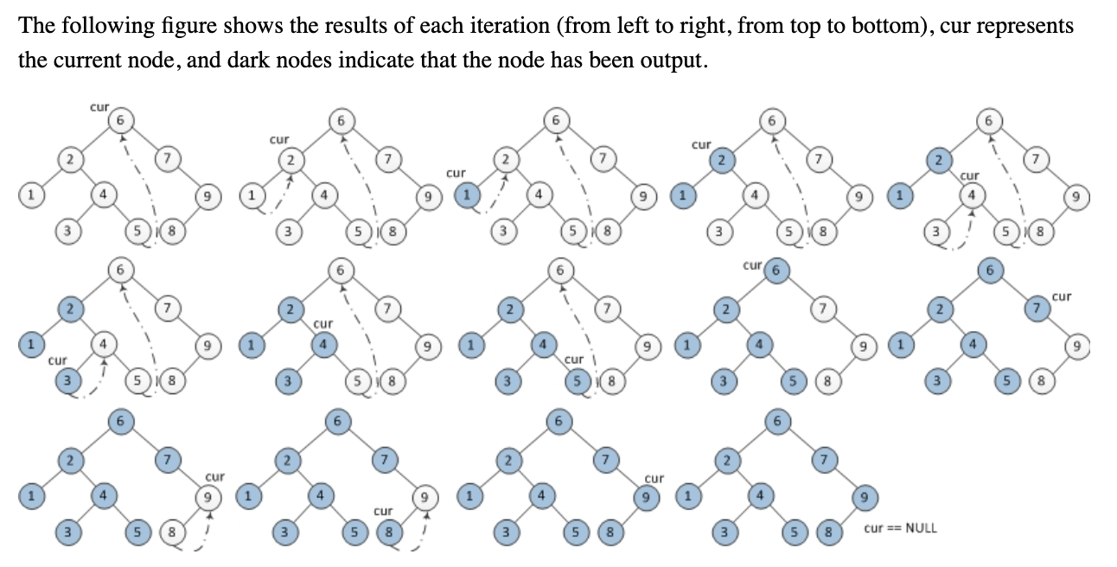

Lecture:-

[](https://www.youtube.com/watch?v=80Zug6D1_r4)

Code

class TreeNode:

    def __init__(self, value):

*self*.value = value

*self*.left = None

*self*.right = None

def morris_inorder_traversal_bst(root):

    result = []

    cur = root

    while cur:

        if not cur.left:

            result.append(cur.value)

            cur = cur.right

        else:

*# Find the inorder predecessor(right most node of left subtree)*

            prev = cur.left

            while prev.right and prev.right != cur:

                prev = prev.right

*# Make current as the right child of its inorder predecessor*

            if not prev.right:

                prev.right = cur

                cur = cur.left

            else:

*#if there is already linkage*

*# Revert the changes made in the 'if' part to restore the original tree*

                prev.right = None

                result.append(cur.value)

                cur = cur.right

    return result

*# Example usage:*

*# Construct a sample Binary Search          4*

*#                                          / *

*#                                         2   5*

*#                                       /  *

*#                                      1    3*

root_bst = TreeNode(4)

root_bst.left = TreeNode(2)

root_bst.left.left = TreeNode(1)

root_bst.left.right = TreeNode(3)

root_bst.right = TreeNode(5)

result_bst = morris_inorder_traversal_bst(root_bst)

print(result_bst)

*# Output:[1,2,3,4,5]*

Execution:

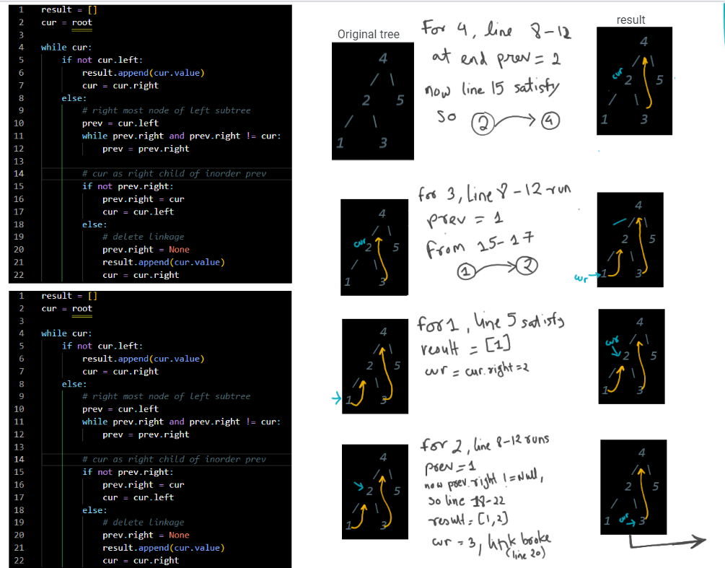

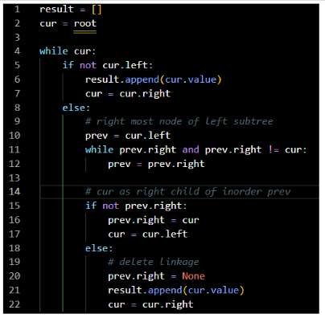 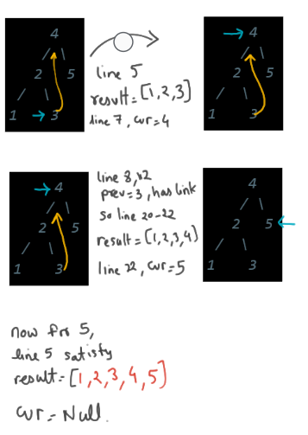

# LEVEL 1: **Armature**

### Sum of binary tree

Link: [https://www.geeksforgeeks.org/problems/sum-of-binary-tree/1](https://www.geeksforgeeks.org/problems/sum-of-binary-tree/1?page=1&category=Tree,Binary%20Search%20Tree&difficulty=Basic&sortBy=accuracy)

### Search a node in BST

Link: [https://www.geeksforgeeks.org/problems/search-a-node-in-bst/1](https://www.geeksforgeeks.org/problems/search-a-node-in-bst/1?page=1&category=Tree,Binary%20Search%20Tree&difficulty=Basic&sortBy=accuracy)

### Count Leaves in binary tree

Link: [https://www.geeksforgeeks.org/problems/count-leaves-in-binary-tree/1](https://www.geeksforgeeks.org/problems/count-leaves-in-binary-tree/1?page=1&category=Tree,Binary%20Search%20Tree&difficulty=Basic&sortBy=accuracy)

### N-Ary Tree postorder traversal

Link: [https://leetcode.com/problems/n-ary-tree-postorder-traversal/](https://leetcode.com/problems/n-ary-tree-postorder-traversal/?envType=problem-list-v2&envId=tree)

### Maximum Depth of binary tree

Link: [https://www.geeksforgeeks.org/problems/maximum-depth-of-binary-tree/1](https://www.geeksforgeeks.org/problems/maximum-depth-of-binary-tree/1?page=1&category=Tree,Binary%20Search%20Tree&difficulty=Easy&sortBy=accuracy)

### Height of binary tree

Link: [https://www.geeksforgeeks.org/problems/height-of-binary-tree/1](https://www.geeksforgeeks.org/problems/height-of-binary-tree/1?page=1&category=Tree,Binary%20Search%20Tree&difficulty=Easy&sortBy=accuracy)

### Convert a BST to tree with only right nodes.

Link: <https://leetcode.com/problems/increasing-order-search-tree/description/>

### Check if two binary trees are same or not.

Link: <https://leetcode.com/problems/same-tree/description/>

### Range sum of bst

Link: <https://leetcode.com/problems/range-sum-of-bst/description/>

### Average of levels in binary tree.

Link: <https://leetcode.com/problems/average-of-levels-in-binary-tree/description/>

### Sum of left leaves

Link: <https://leetcode.com/problems/sum-of-left-leaves/description/>

### Invert a binary tree

Link: <https://leetcode.com/problems/invert-binary-tree/>

# LEVEL 2: **Pro**

### Merge two binary trees.

Link: <https://leetcode.com/problems/merge-two-binary-trees/description/>

### Sorted array to BST

Link: <https://leetcode.com/problems/convert-sorted-array-to-binary-search-tree/description/>

### Binary Tree tilt

Link: <https://leetcode.com/problems/binary-tree-tilt/description/>

### Diameter of binary tree

Link: <https://leetcode.com/problems/diameter-of-binary-tree/description/>

### Subtree of another tree

Link: <https://leetcode.com/problems/subtree-of-another-tree/description/>

### Sum of Nodes with Even-Valued Grandparent

Link: <https://leetcode.com/problems/sum-of-nodes-with-even-valued-grandparent/>

### Balance a binary search tree

Link: <https://leetcode.com/problems/balance-a-binary-search-tree/>

# LEVEL 3: **Legend**

# **SOLUTIONS:**

## **LEVEL 1:**

1. Sum of binary tree

*#Approach 1: using seperate inorder traversal method and using global variable*

class Solution:

    def sumBT(*self*, *root*):

*#run inorder traversal and get sum of all*

        def inorder(*root*):

            global ans

*if* *root* is not None:

                inorder(*root*.left)

                ans+=*root*.data

                inorder(*root*.right)

        global ans

        ans=0

        inorder(*root*)

*return* ans

*#Approach 2: using just plain recursion without global keyword*

class Solution:

    def sumBT(*self*, *root*):

*if* *root* is None:

*return* 0

        l=*self*.sumBT(*root*.left)

        r=*self*.sumBT(*root*.right)

*return* *root*.data + l + r

*#Appproach 3(shorter)*

class Solution:

    def sumBT(*self*, *root*):

*return* *root*.data+*self*.sumBT(*root*.left)+*self*.sumBT(*root*.right) *if* *root* *else* 0

1. Search a node in BST

class BST:

    def search(*self*, *node*, *x*):

*if* *node* is None:

*return* False

*if* *node*.data==*x*:

*return* True

*if* *node*.data>*x*:

*return* *self*.search(*node*.left,*x*)

*return* *self*.search(*node*.right,*x*)

1. Count Leaves in binary tree

class Solution:

    def countLeaves(*self*, *root*):

*if* *root* is None:

*return* 0

*#Means it is leave, so no need to iterate further subtree of it*

*if* *root*.left is None and *root*.right is None:

*return* 1

*return* *self*.countLeaves(*root*.left) + *self*.countLeaves(*root*.right)

1. N-Ary tree postorder traversal

class Solution:

    def postorder(*self*, *root*: 'Node') -> List[int]:

*#postorder:left right root*

        def helper(*node*):

*if* *node*:

*for* temp *in* *node*.children:

                    helper(temp)

                ans.append(*node*.val)

        global ans

        ans=[]

        helper(*root*)

*return* ans

1. Maximum depth of binary tree

class Solution:

    def maxDepth(*self*,*root*):

*if* *root* is None:

*return* 0

*if* not *root*.left and not *root*.right:

*return* 1

        l = *self*.maxDepth(*root*.left)

        r = *self*.maxDepth(*root*.right)

*return* 1+max(l,r)

1. Height of binary tree

class Solution:

    def height(*self*, *root*):

*# code here*

*if* *root* is None:

*return* 0

*#this is end condition but since if we return 1 from here, it will be count of nodes*

*#to get edge count (edge count =  node count-1) , so return 0*

*if* not *root*.left and not *root*.right:

*return* 0

        l = *self*.height(*root*.left)

        r = *self*.height(*root*.right)

*return* 1+max(l,r)

1. Convert BST to inorder tree with only right node

*# Approach : first get the inorder traversal*

*#create a new tree and add all values to right subtree*

class Solution:

    def increasingBST(*self*, *root*: TreeNode) -> TreeNode:

        def inorder(*root*):

*return* inorder(*root*.left)+[*root*.val]+inorder(*root*.right) *if* *root* *else* []

inorder_trav = inorder(*root*)

        temp=TreeNode()

        ans=temp

*for* val *in* inorder_trav:

            temp.right = TreeNode(val)

            temp = temp.right

*return* ans.right

1. Same tree

class Solution:

    def isSameTree(self, p: Optional[TreeNode], q: Optional[TreeNode]) -> bool:

        if p is None and q is None:

            return True

        if (p is None) or (q is None):

            return False

        if p.val!=q.val:

            return False

        return self.isSameTree(p.left,q.left) and self.isSameTree(p.right,q.right)

Approach 2

class Solution:

    def isSameTree(*self*, *p*: Optional[TreeNode], *q*: Optional[TreeNode]) -> bool:

*#while q* *for i in range q, popleft current one, popleft from other one, if they arent #equal, break* *add left if left, add right. same for other one*

        q1 = deque([*p*])

        q2 = deque([*q*])

*while* q1:

*if* len(q1) != len(q2):

*return* False

*for* i *in* range(len(q1)):

                curr1 = q1.popleft()

                curr2 = q2.popleft()

*if* not curr1 and not curr2:

*continue*

*if* not curr1 or not curr2:

*return* False

*if* curr1.val != curr2.val:

*return* False

                q1.append(curr1.left)

                q1.append(curr1.right)

                q2.append(curr2.left)

                q2.append(curr2.right)

*return* True

1. Range sum of bst

[Solution](https://leetcode.com/problems/range-sum-of-bst/solutions/4558641/python-fastest-optimized-with-explanation/)

class Solution:

    def rangeSumBST(self, root: Optional[TreeNode], low: int, high: int) -> int:

        def travel(root):

            global ans

            if (root is None) :

                return

            else:

                if root.val>=low and root.val<=high:

                    ans+=root.val

                if root.val >low:

                    travel(root.left)

                if root.val <high:

                    travel(root.right)

        global ans

        ans=0

        travel(root)

        return ans

Approach 2: without global value

class Solution:

    def rangeSumBST(*self*, *root*: Optional[TreeNode], *low*: int, *high*: int) -> int:

*if* *root* is None:

*return* 0

*if* *root*.val<*low*:

*return* *self*.rangeSumBST(*root*.right,*low*,*high*)

*if* *root*.val>*high*:

*return* *self*.rangeSumBST(*root*.left,*low*,*high*)

*return* *root*.val+*self*.rangeSumBST(*root*.left,*low*,*high*)+*self*.rangeSumBST(*root*.right,*low*,*high*)

1. Average of levels in binary tree

*#Approach: iterate normally but maintain level*

*#res[level]= [sum_of_all_values_in_level , count_of_elemets_in_level]*

class Solution:

    def averageOfLevels(*self*, *root*: Optional[TreeNode]) -> List[float]:

        res=[]                 *#[[level_sum,count_of_elements]]*

        def dfs(*node*, *lvl*=0):

*if* not *node*:

*return*

*if* len(res)<*lvl*+1: *#means for level+1, there is no res, so add*

                res.append([0,0])

            dfs(*node*.left, *lvl*+1)

            res[*lvl*][0]+=*node*.val

            res[*lvl*][1]+=1

            dfs(*node*.right, *lvl*+1)

        dfs(*root*)

*return*[i/k *for* i,k *in* res]

*#Approach 2: using breadth level traversal*

from collections import deque

class Solution:

    def averageOfLevels(self, root: Optional[TreeNode]) -> List[float]:

        ans=[]

        queue = deque()

        queue.append(root)

        while(queue):

            temp = 0

            l = len(queue)

            for i in range(l):

                t = queue.popleft()

                temp+=t.val

                if t.left:

                    queue.append(t.left)

                if t.right:

                    queue.append(t.right)

            ans.append(temp/l)

        return ans

1. Sum of left leaves

class Solution:

    def sumOfLeftLeaves(*self*, *root*: Optional[TreeNode]) -> int:

        def leftSum(*node*,*isLeft*):

*if* *node*:

*if* *isLeft* and (not *node*.left and not *node*.right):

*self*.ans+=*node*.val

                leftSum(*node*.left,True)

                leftSum(*node*.right,False)

*#in place of global can use self also*

*self*.ans=0

        leftSum(*root*,False)   *#if single node is there, it is not consider left leaf*

*return* *self*.ans

1. Invert a Binary tree

class Solution:

    def invertTree(self, root: Optional[TreeNode]) -> Optional[TreeNode]:

        if root:

            v1 = self.invertTree(root.left)

            v2 = self.invertTree(root.right)

            root.left = v2

            root.right = v1

        return root

easier way

class Solution:

    def invertTree(self, root: Optional[TreeNode]) -> Optional[TreeNode]:

        if root is None:

            return root

        else:

            root.left , root.right = self.invertTree(root.right) , self.invertTree(root.left)

            return root

## **LEVEL 2:**

1. Merge two binary tree

class Solution:

    def mergeTrees(self, root1: TreeNode, root2: TreeNode) -> TreeNode:

        if root1 is None:

            return root2

        if root2 is None:

            return  root1

        root1.val = root1.val + root2.val

        root1.left = *self*.mergeTrees(root1.left,root2.left)

        root1.right = *self*.mergeTrees(root1.right,root2.right)

        return root1

1. Sorted Array to binary Search tree

[Solution](https://leetcode.com/problems/convert-sorted-array-to-binary-search-tree/solutions/4565640/python-code-fastest-solution-explanation/)

[](https://www.youtube.com/watch?v=0K0uCMYq5ng)

class Solution:

    def sortedArrayToBST(self, nums: List[int]) -> Optional[TreeNode]:

        def helper(l,r):

            if l>r:

                return

            else:

                m = (l+r)//2

                root = TreeNode(nums[m])

                root.left = helper(l,m-1)

                root.right = helper(m+1,r)

                return root

        return helper(0,len(nums)-1)

1. Binary tree tilt

[Solution](https://leetcode.com/problems/binary-tree-tilt/solutions/4578246/python-2-solutions-easy-one-optimized-version-with-explanation/)

class Solution:

    def findTilt(self, root: TreeNode) -> int:

        def helper(root):

            if not root: return 0

            lv, rv = helper(root.left), helper(root.right)

*self*.ans += abs(lv - rv)

            return root.val + lv + rv   *#This gives sum of given subtree*

*self*.ans = 0

        helper(root)

        return *self*.ans

1. Diameter Of Binary tree

[Solution](https://leetcode.com/problems/diameter-of-binary-tree/solutions/1143907/python-thought-process/)

[](https://www.youtube.com/watch?v=bkxqA8Rfv04)

def diameterOfBinaryTree(self, root):

    def recurse(node):

        if not node: return 0

        left, right = recurse(node.left), recurse(node.right)

*self*.result = max(*self*.result, left+right)

        return 1 + max(left, right)

*self*.result = 0

    recurse(root)

    return *self*.result

Similar way try to code for finding height of binary tree.

1. Subtree of another tree

class Solution:

    def isSubtree(self, root: Optional[TreeNode], subRoot: Optional[TreeNode]) -> bool:

        if subRoot == None :

            return True

        if root == None :

            return False

        if *self*.same(root , subRoot):

            return True

        return *self*.isSubtree(root.left , subRoot) or *self*.isSubtree(root.right , subRoot)

*#This is code to check if one tree is equal to other*

*#check root vals and left and right subtree vals, can't do r==s(this don't work)*

    def same(self , r , s):

        if r == None and s == None :

            return True

        if r and s and r.val == s.val:

            return *self*.same(r.right , s.right) and *self*.same(r.left , s.left)

        return False

1. Sum of Nodes with Even-Valued Grandparent

Take variables for parent and grand parent, and whenever a new child is encountered, make current node as parent and existing parent as grandparent.

class Solution:

    def sumEvenGrandparent(self, root: Optional[TreeNode]) -> int:

        global sum

        sum=0

        def dfs(node,par,gp):

            global sum

            if not node:

                return

            dfs(node.left,node,par)

            if gp and gp.val%2==0:

                sum += node.val

            dfs(node.right,node,par)

        dfs(root,None,None)

        return sum

Approach 2: handling parent and grandparent value only

class Solution:

    def sumEvenGrandparent(self, root: Optional[TreeNode]) -> int:

        def doer(root,pvalue,gvalue):

            if not root:

                return 0

            val=root.val if gvalue%2==0 else 0

            return val + doer(root.left,root.val,pvalue)+doer(root.right,root.val,pvalue)

        return doer(root,-1,-1)

1. Balance a Binary Search Tree

Will first get the inorder traversal of existing tree. Now with that inorder traversal, we will start creating a binary tree by taking mid element and placing elements left to mid in left tree and ones present right to mid element to right subtree. Will do this recursively till all elements are placed correctly.

class Solution:

    def inorder(self,root):

        return self.inorder(root.left) + [root.val] + self.inorder(root.right) if root else []

    def constructBinary(self,arr,left,right):

        if left>right:

            return None

        mid = (left+right)//2

        parent = TreeNode(arr[mid])

        parent.left = self.constructBinary(arr,left,mid-1)

        parent.right = self.constructBinary(arr,mid+1,right)

        return parent

    def balanceBST(self, root: Optional[TreeNode]) -> Optional[TreeNode]:

        inorder_arr = self.inorder(root)

        parent = self.constructBinary(inorder_arr, 0,len(inorder_arr)-1)

        return parent